Title: Part 9 input XML hints (draft)

S-100 Maintenance - Change Proposal Form

|  |  |  |  |
| --- | --- | --- | --- |
| **Organisation** | NIWC | **Date** | 2/22/2021 |
| **Contact** | David Grant | **Email** | David.Grant1@navy.mil |

Change Proposal Type *(Select only one option)*

|  |  |  |
| --- | --- | --- |
| 1.Clarification | 2.Correction | 3.Extension |
|  |  | X |

Location (*Identify all change proposal locations)*

|  |  |  |  |
| --- | --- | --- | --- |
| S-100 Version No. | Part No. | Section No. | Proposal Summary |
| Draft 5.0 | 9 | 9-7  Appendix 9-A | See attached redlines (TODO) |

Change Proposal

Updates the portrayal catalogue schema (attached) to provide hints for optimized generation of XSLT portrayal input. Updates Part 9-7 and Appendix 9-A to describe use of the input hints.

Change Proposal Justification

TSM7-5.9 “Issues with the Part 9-7 Data Input Schema” presented the justification for this change as recommendation 4.

The current XSLT portrayal processing is inefficient because the input XML must encode the entire dataset, including the geometries of all spatial objects. Most of these geometries are not evaluated by the portrayal rules, and if excluded would significantly reduce the size, encoding time, and processing time of the input XML.

The proposal is an extension to the portrayal catalogue schema; it allows portrayal catalogue developers to (optionally) provide hints to optimize generation of the input XML. OEMs may use these hints (when provided) to speed up portrayal processing, but are not required to do so. It is expected that these entries will be populated over time based on feedback from OEMs.

Summary:

- Provides hints which can be used to reduce the size, encoding time, and processing time of the input XML

- Allows hints to be set globally and overridden for individual feature or spatial types

- Attributes can be filtered per-feature type

- hints can be associated with TopLevelTemplates

Limitations:

- Does not allow overrides for specific feature type / attribute value / association combinations (e.g. buoys with radar reflectors, or buoys associated with lights)

The sample hint shown below indicates all spatial coordinates may be omitted other than those associated with MultiPoints; this is the entry which is expected to be provided by the portrayal catalogue for most product types.

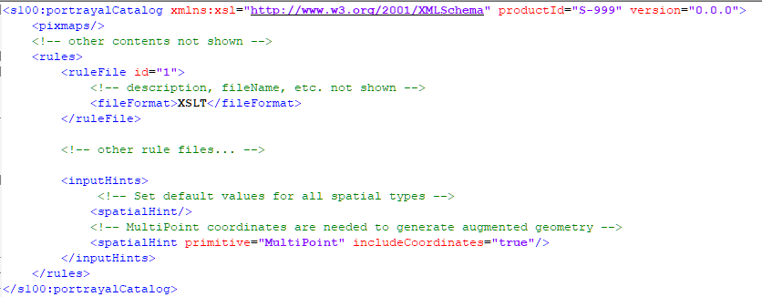

A more complex example. Only four feature types are used by the portrayal.

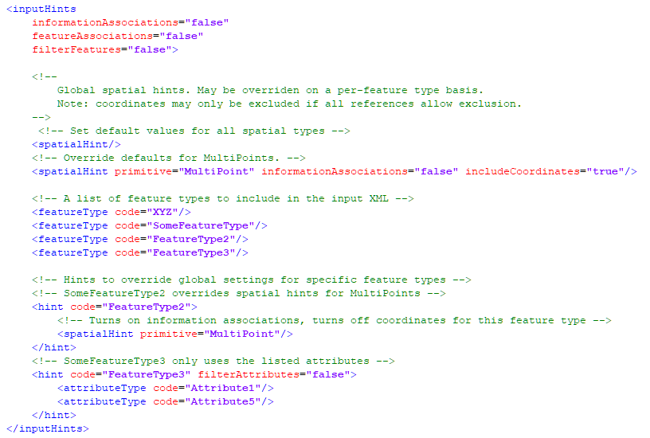

What parts of the S-100 Infrastructure will this proposal affect?

S-100 Feature Concept Dictionary Interface or Database

S-100 Portrayal Register

S-100 Feature Catalogue Builder

S-100 Portrayal Catalogue Builder

S-100 UML Models

S-100 GitHub Schemas

**Please send completed forms and supporting documentation to the secretary S-100WG.**